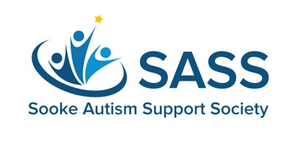

SIBSHOPS REGISTRATION FORM
SPRING 2024
WHAT IS SIBSHOPS?
SibKids is a fun and welcoming group where the siblings of kids with special needs can meet new friends, play games, and do projects. Discussion activities and interaction with peers provide support around the unique issues they experience. Each professionally-facilitated session includes games, activities, discussions, and a light snack.
WHO IS SIBSHOPS FOR?
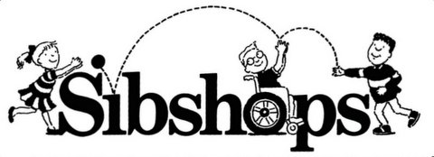
The group is best suited for children aged 7-11. If you have a child slightly older or younger that would like to participate, you are invited to reach out to Corrina to discuss whether this group would be a good fit for them.
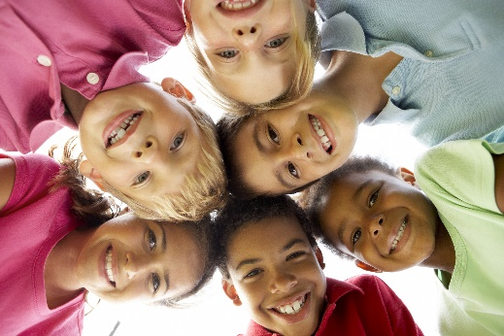
WHEN & WHERE IS SIBSHOPS?
- Seaparc Leisure Centre – Multipurpose Room
- Wednesday After School from 3:30-5:30 pm
- June 5, 12, 19 & 26 (4 weeks)
- Registration Fee is $25 for all 4 sessions
HOW DO I REGISTER MY CHILD FOR SIBSHOPS?
To register your child, please:

- Complete the information on the next page and email it to Sooke.sass@gmail.com or drop it off to 6489 Beechwood Place (Sunriver)
- Once you receive confirmation from SASS that your child has a spot, send a $25 e-Transfer to secure your registration.
- Registration is open until May 15 2024 or until all spaces are taken. Space is limited.

Parent(s) / Legal Guardian Name(s): _____________________________________________________________
Mailing Address: _____________________________________________________________________________

Phone: Cell: __________________________Work: ________________________ Home: ____________________

Email: __________________________________________________

EMERGENCY CONTACT: Name: ___________________________________________________________
(other than parent)

Relationship: _____________________________________ Phone: ________________________________

PARTICIPANT INFORMATION:

Name of child participating in Sibshops: ___________________________________________________ Age: ______

Birthdate: ________________________ DD/MM/YYYY Gender: ____________________

School attending: __________________________________________________________________ Grade: ______

Care Card #: ______________________________ Physician: ___________________________________________

Allergies, food, or health/behavior concerns: __________________________________________________________

Name of sibling with special needs: _______________________________________________ Age (of sibling): _____

Nature of special needs: __________________________________________________________________________

Registration cannot be guaranteed until registration form and fees are received.

I hereby agree to indemnify, release and save harmless Sooke Autism Support Society (SASS) and its employees or contractors for any loss or damage through personal injury or otherwise and claims arising from any accident or sickness to the participant. *Including the transportation of your child in the event of an emergency.

Signed: ___________________________________________ Date: _______________________________

Photograph Permission to Release Form

I understand and am in agreement that the photograph(s) taken of my child during their participation in the Sibshop program may be used for promotion and publicity purposes for the Sooke Autism Support Society (SASS), including posting on their respective Websites.

- Yes, I give Consent
- No, I do Not give Consent

Signed: __________________________________________ Date: _______________________________

If you are unable to cover the Registration Fee, please let us know and we will be happy to assist you.

