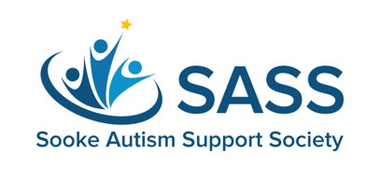
Inclusion Recognition Award 2022

The Sooke Autism Support Society (SASS) Inclusion Recognition Award is open to any graduating student at EMCS who has demonstrated an enthusiastic commitment to promoting the positive inclusion of those with special needs at home, at school and/or within the community.
We are delighted to reward and recognize those who actively promote the inclusion of those with special needs in the home, at school and in the community in a variety of ways. These types of individual have a profound impact on the Special Needs people they support, the families of those with Special Needs and the entire community. We want to promote more of this in our beautiful town of Sooke.
Items required for application to this award are as follows:
- Complete the attached Application Form
- Letter of Reference from someone who can describe and endorse your efforts to include an individual or individuals with special needs
- Personal Essay on the specific ways you’ve promoted inclusion of those with special needs and what you’ve learned through this endeavour (approximately 600-800 words)
You do not need to be pursuing any further studies or schooling to apply for this award – it is open to all graduating students of EMCS in June 2022.
The SASS Inclusion Recognition Award is $500
Deadline for Applications is Monday, May 2nd 2022.

Website www.sooke-sass.com
Email sooke.sass@gmail.com
Facebook Sooke Autism Support System

Inclusion Recognition Application Form 2022

Name: Click and type
Address: Click and type
Phone Number: Click and type
Email Address: Click and type
Please check off the different ways you have promoted the inclusion of special needs at home, at school or in the community.

EMCS Peer Tutoring
EMCS Other (please specify) Click and type
School or Community Sport organization involved with Special Needs players
Seaparc Summer Camp Leader involved with Special Needs players
Work with an organization supporting those with Special Needs
Volunteer with an organization supporting those with Special Needs
Work with an organization like Big Brothers/Big Sisters with Special Needs
Assist at home with a sibling or family member who has Special Needs
Other (please specify) Click and type
I’ve included the following with my APPLICATION FORM:
Letter of Reference from someone who can describe and endorse my efforts to include those with special needs.
Personal Essay on the specific ways you’ve promoted inclusion of those with special needs and what you’ve learned through this endeavour (approximately 600-800 words).
Any Other Items which demonstrate my commitment to inclusion (Optional).

This can be an SD62 Representative (Principal, Vice Principal, Teacher, etc.), Employer, Representative of a School or Community sporting organization or other reputable individual who can advocate and endorse your commitment to inclusion.

