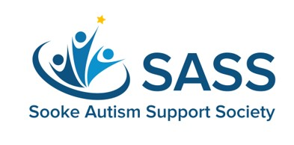
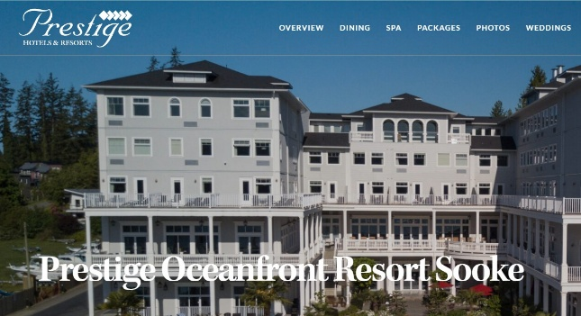

SASS CAREGIVE RESPITE APPLICATION FORM 2026

The Sooke Oceanfront Prestige Resort has generously provided SASS with a 1-Night Complimentary Stay for one of our SASS families . This respite will allow caregivers an important opportunity to REST & RECHARGE - taking a necessary break from their family so they can come back refreshed and restored!
Applications are DUE on/by February 13 2026 and can be submitted directly to SASS as follows:
EMAIL sooke.sass@gmail.com
MAIL 6489 Beechwood Place, Sooke BC V9Z0Y7
We are so deeply GRATEFUL for the support we are receiving from the Prestige Oceanfront Resort Sooke - we are so fortunate to have such a wonderful & supportive community in Sooke
Everything provided in this email is KEPT PRIVATE & CONFIDENTIAL * Click & Type or Handwrite

CAREGIVER INFORMATION
NAME: Click and type
EMAIL: Click and type
CELLPHONE: Click and type
I am confirming that I am a primary caregiver for a loved one who has special needs: Yes No
Nature of special needs: Click and type
Are finances a concern for your family when it comes to getting away for respite? Yes No
Do you have someone who can care for your loved one while you enjoy a night away? Yes No
Please share with us how the provision of this SASS Respite Package will help you and your family.
Click and type

